* Create an Employee class with the following specifications.
* Employee Name as string.
* Basic Salary, HRA, DA, TAX, Gross Pay and Net salary as decimal.
* Calculate the HRA (15% of Basic Salary), DA (10% of Basic Salary), Gross Pay (Basic Salary + HRA + DA), Tax (8% of Gross Pay) and Net Pay (Gross Pay – Tax).
* A Constructor to allow to define the Employee Name and Basic Salary.
* A method CalculateNetPay to calculate the HRA, DA, Tax, Gross and Net Pay values using the criteria mentioned in the Point 4.
* A method Display to Display the Salary structure

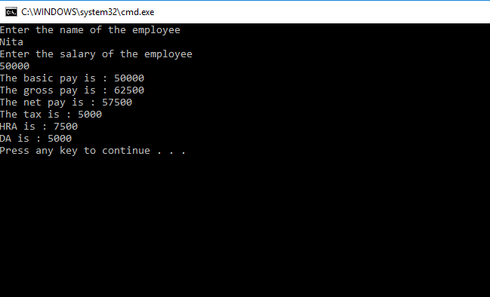

* Create a new class called “RandomHelper” which contains the following:
* A static method called randint that accepts two integers and returns a random integer between them. Make sure that the numbers are inclusive (i.e. if you call randomint(1,10) you should be able to generate both 1 and 10.
* A static method called randdouble that accepts two integers and returns a random double between them. For this method you should be able to generate numbers such that 1 <= x < 10 for the method call randdouble(1,10)
* Call your method from another class without instantiating the class (i.e. call it just like you would call Math.random() since your methods are defined to be static)

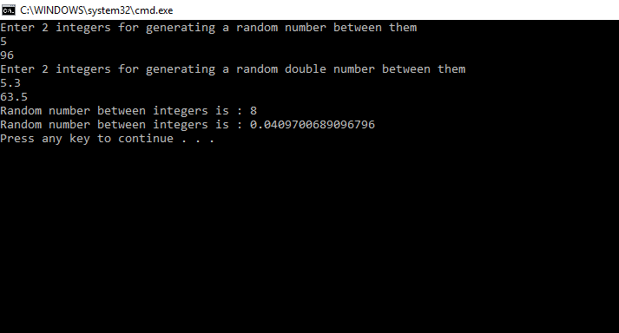

* Design a class that implements a Fan. Here’s what your class should contain:
* Static constants SLOW, MEDIUM and FAST that store the integers 1, 2 and 3
* Private int named speed that defaults to SLOW
* Private boolean named on that defaults to false
* Private double named radius that defaults to 5
* Private String named color that defaults to “red”
* A no-arg constructor
* Getters and setters for each field, making sure to perform appropriate data vaildation prior to making changes to any field
* A method toString() that returns a String summary of the current status of your fan

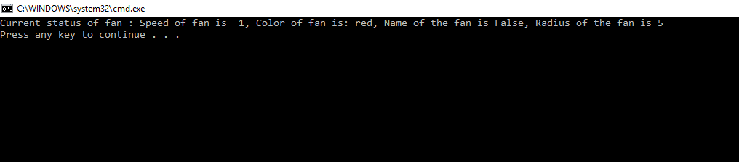

* Create a class called Person with a member variable name. Save it in a file called Person.cs. Create a class called Employee who will inherit the Person class. The other data members of the employee class are annual salary (double), the year the employee started to work, and the national insurance number which is a String. Save this in a file called Employee.cs . Your class should have a reasonable number of constructors and accessor methods. Write another class called TestEmployee, containing a main method to fully test your class definition.

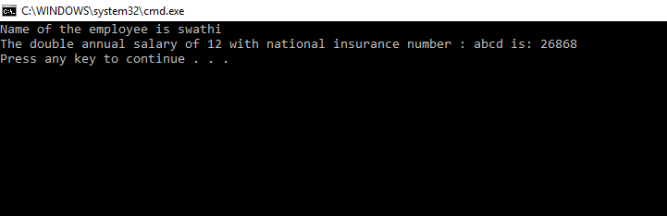

* Create an abstract class Instrument which is having the abstract function play. Create three more sub classes from Instrument which is Piano, Flute, Guitar. Override the play method inside all three classes printing a message
* “Piano is playing tan tan tan tan ” for Piano class
* “Flute is playing toot toot toot toot” for Flute class
* “Guitar is playing tin tin tin ” for Guitar class

You must not allow the user to declare an object of Instrument class. Create an array of 10 Instruments. Assign different type of instrument to Instrument reference. Check for the polymorphic behavior of play method. Use the instanceof operator to print that which object stored at which index of instrument array.

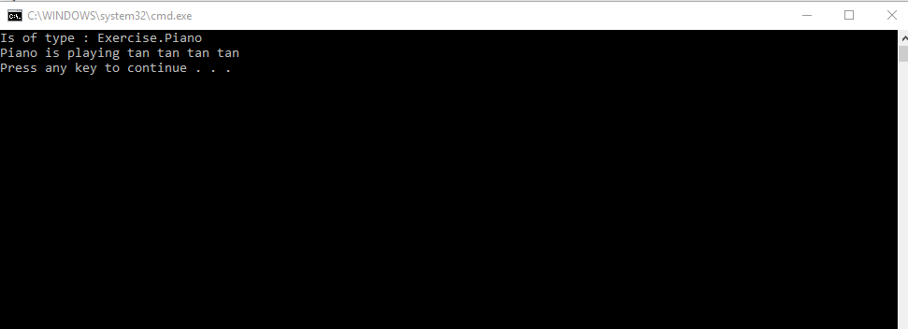

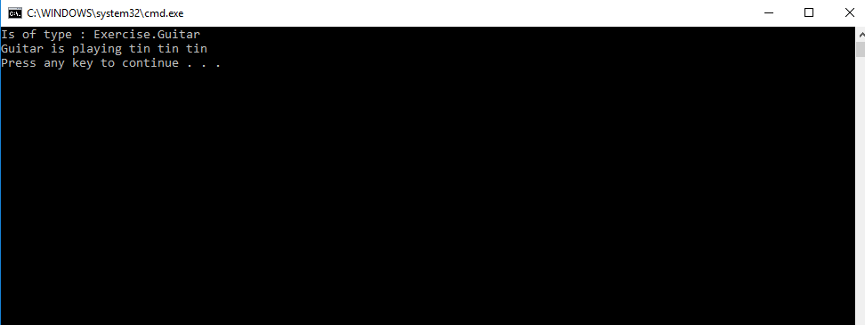

* Create a base class Fruit which has name ,taste and size as its attributes. A method called eat() is created which describes the name of the fruit and its taste. Inherit the same in 2 other class Apple and Orange and override the eat() method to represent each fruit taste.

